Tonight's Cast

Emcees Dan & Leif
Trixie Jordan
Frank N. Furter Steffan
Brad Majors Jesus
Janet Weiss Megan
Riff Raff Paco
Magenta Laura
Columbia Mandi
Dr. Scott Tim
Eddie Tracy
Rocky Jason
Crim Leif
Phantom Dan & Paco

Transylvanians

Poncho Andrew
Peter Carlos Kayla Shay

Midnight Mafioso

Stage Director: Brandon Stage Director: Mandi
Technical Director: Steffan Technical Director: Zac
Tranny Coordinator: Cheryl Webmaster: Bill
Sound: Tracy & Leif Secretary: Aleah
Accountant: Kim Juu Photographers: Liz
Props Foxes: Jo & Shevaun House Manager: Tracy & Drew
Security: Mark, Kay Kay, Jasmine, Fluffy, Data
Merchandise: Amy, Jenna, Dakota
Spotlights: Kim, Lara, Christina, Nikkie, Kate
Scenic Tech: Zac, Mit, E van, Eddie, Paco

Denton Times
www.midnightinsanity.org
Hi there, dorks and dweebs, and welcome to another hair raising experience here at Midnight Insanity. If you weren't at the show last week, you missed a hot hot hot Valentine's Lingerie Night...so shame on you!! Double shame if you were skipping our show and you weren't getting laid at the time. And don't forget, we have our monthly Lingerie Night next weekend, so make sure you don't miss that!! This week, however, is another "normal show"...or as normal as we're known to get. But we have *two* special shows on the schedule for next month, so be sure to read below for more information on our fabulous new theme nights!! Just remember, we're here every fucking week, just for YOU, so make sure to keep on coming...and cumming...back for more!!
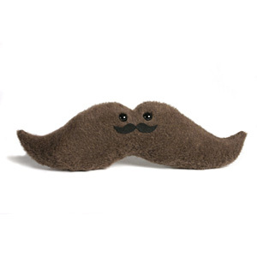
Coming up on March 5th, we start the month off right with Midnight Insanity's March Moustache Madness Night!! That's right. Moustaches. Need we say more? We'll be having a contest for the most awesome, bodacious, bad ass moustache in the mutha fuckin house. Only the most original and unique mustachioed audience members need apply, so make sure to pull some nifty little tricks outta those ass cheeks for this theme night.

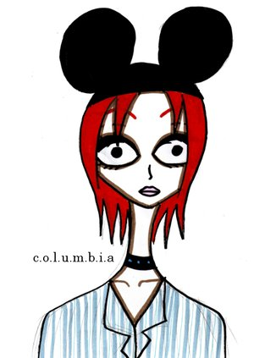

The following weekend, March 12th, be here for a theme night that has been years in the making...Disney Night!! Not only will you see your favorite Rocky Horror characters in Disney garb, but we have a special performance planned that will blow your freaking mind. It's hot. PLUS we'll be having a costume contest. You CANNOT miss this show!!

Like what you see? Want to join the eleganza that IS Midnight Insanity? Well lucky for you, we're always looking for some unsuspecting, innocent young thangs to corrupt. You don't get paid, but you get invited to our kick ass parties, meet some really awesome people, and channel your creativity into something besides your weekly-underwater-basket-weaving-class. So talk to Brandon or Mandi about what you need to do to join our little family...er cult...er cast. Yes, join our happy, harmonious, harmless little cast.
'
Have some suggestions for the show? A theme night you'd like to see? A virgin sacrifice you'd like to watch? Adoring fan mail for our oh so sexy cast members? E-mail us! It's easy, just send your message to: <cast member's first name>@midnightinsanity.org. For example, to tell our sparkly disco ball how much you love her tap dance, just email mandi@midnightinsanity.org!

Brandon's Nonsensical Ramblings:
"Wrinkly balls."

